

NAME: Manan Verma SEMESTER: 4th
SECTION: 24_AIT_KRG-G1 UID: 24BAI70008
SUBJECT CODE: 24CSH-298
FACULTY’S NAME: Mr. SHALABH BHATIA

Topic : Experiment 3

AIM :
To understand the basic structure of a PL/SQL program by creating and executing a simple PL/SQL block that includes declaration and execution sections, and to display output using built-in procedures.

Software Requirements
- Database Management System:
  - PostgreSQL
- Database Administration Tool:
  - pgAdmin

Objective:
To create a simple PL/SQL program demonstrating Declaration Section and Execution Section.

Problem Statement:

Design and implement a simple PL/SQL program that demonstrates the basic structure of a PL/SQL block. The program should include a declaration section to define variables and an execution section to perform operations using those variables and display the results using appropriate output statements.

1. Declaration Section (DECLARE)
- Variables are declared and initialized:
  - emp_id → Employee ID
  - emp_name → Employee Name
  - emp_salary → Employee Salary

2. Execution Section (BEGIN ... END)
- DBMS_OUTPUT.PUT_LINE is used to display output.

Procedure:
- Open pgAdmin and connect to the PostgreSQL database server.
- Create an employee table with employee ID, name, and salary.
- Insert sample data into the employee table.
- Write a PL/pgSQL anonymous block using the DO $$ command.
- Declare variables in the DECLARE section to store employee details.

6.In the BEGIN…END section:
- Retrieve employee data from the table into variables.
- Perform a basic operation (calculate 10% salary increment).
- Display employee details and calculated salary using output statements.
7.Execute the block and observe the output in the Messages/Notices panel of pgAdmin.
CODE:
CREATE TABLE employee (
emp_id INTEGER PRIMARY KEY,
emp_name VARCHAR(50),
emp_salary NUMERIC
);

INSERT INTO employee VALUES (01, Manan, 980000);
DO $$
DECLARE
v_id INTEGER;
v_name VARCHAR(50);
v_salary NUMERIC;
v_bonus NUMERIC;
BEGIN
SELECT emp_id, emp_name, emp_salary
INTO v_id, v_name, v_salary
FROM employee
WHERE emp_id = 01;

v_bonus := v_salary * 0.10;

RAISE NOTICE 'Employee ID : %', v_id;
RAISE NOTICE 'Employee Name : %', v_name;
RAISE NOTICE 'Original Salary : %', v_salary;
RAISE NOTICE '10%% Bonus Amount : %', v_bonus;
RAISE NOTICE 'Updated Salary : %', v_salary + v_bonus;
END $$;

Outputs:
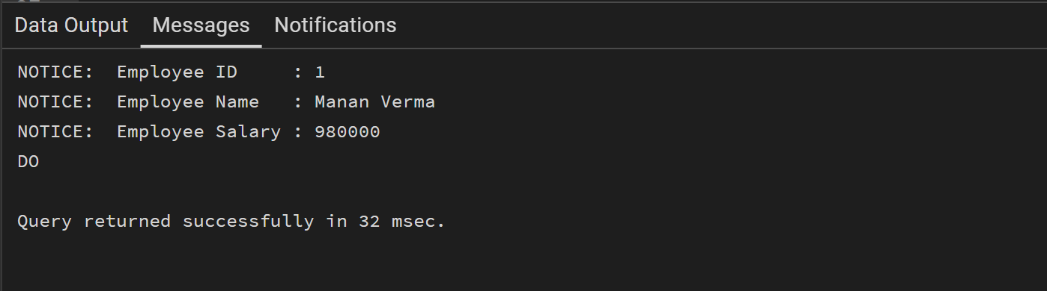
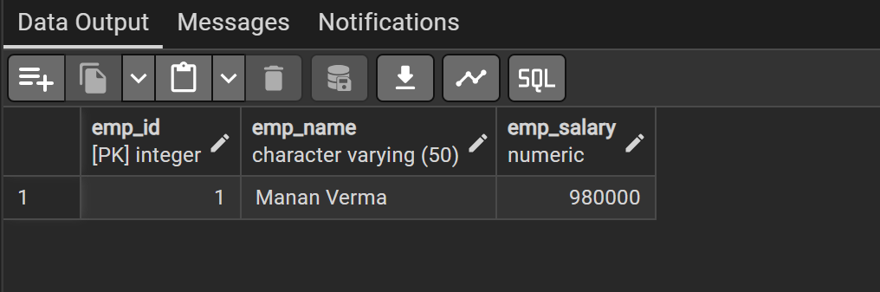
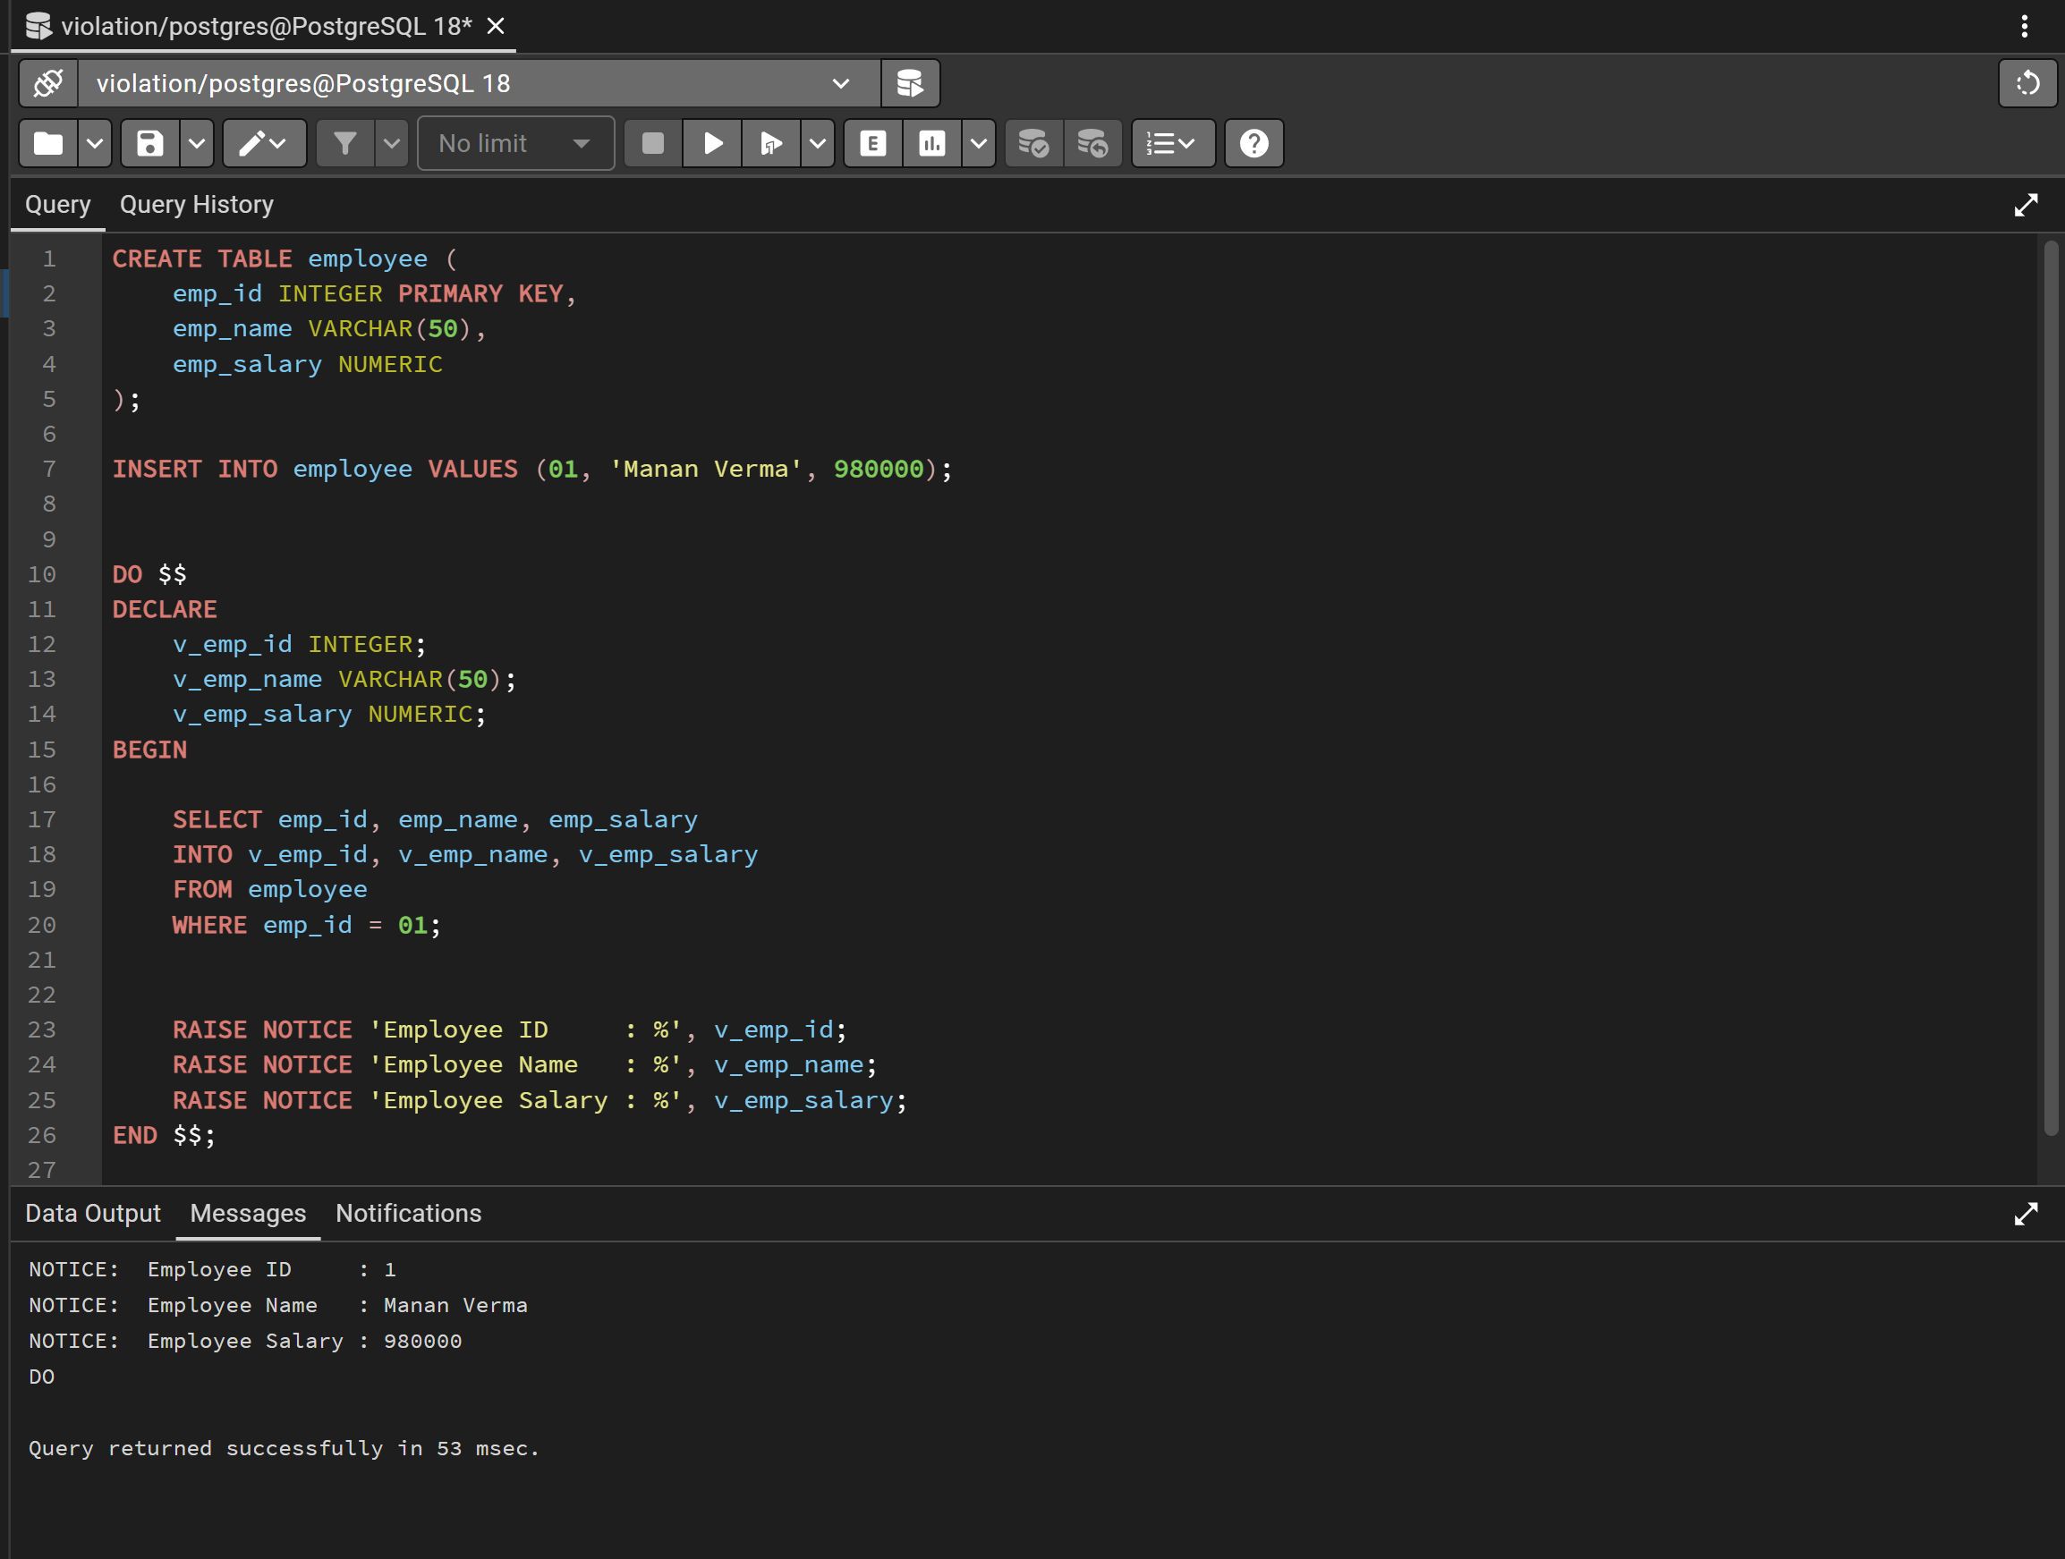

Learning Outcomes:
• Understand the structure of a PL/pgSQL program.
• Use the declaration section to define variables.
• Retrieve data from a table into variables.
• Perform basic arithmetic operations using variables.

